Media Music Performance and Production
Media, Music and Performing Arts/ Production allows our students to study across disciplines whilst specialising in acting, dance, backstage, media or music. Take a look at our Chroma-Q theatre launch event just before lock down and see our talented creative arts students in action:

Quarry Hill Chroma-Q launch – https://drive.google.com/file/d/1J136bDy6FARWu2ID5EtgfqjBzqeR155M/view?ts=5 ee36868

Specialist areas:

Acting

TRANSMIT – View our play in conjunction with Paperbird about the evolution of communication delivered online - https://www.crowdcast.io/e/transmit--online- 2 Password TransmitPerformance2

TRANSMIT press coverage – Yorkshire Post:
https://drive.google.com/file/d/1yfw4d8RXzQmRYDR3vE0JKSBAVBB5uEJ0/view?us p=sharing
BBC Radio News: https://drive.google.com/file/d/1KK4qjnEqVzk9bvwtyE6RotCT59XIyFW9/view?usp=s haring

Embodiment
Video performance of Embodiment – a student performance https://drive.google.com/file/d/1v9j_zqdE5_bRtUeaTuH56bxRTVPlf5sC/view?ts=5eb aa30f

Unsung Collective
During lockdown Creatives haven’t stopped.
Click here www.unsungcollective.com/radio to listen to one of the groups we have supported to continue creating during lockdown. Leeds based all female theatre company "Unsung Collective". We lent them some vocal recording devices which they used to turn their latest play into a radio play rehearsed, performed and recorded in isolation.

Dance - continue

Dance:
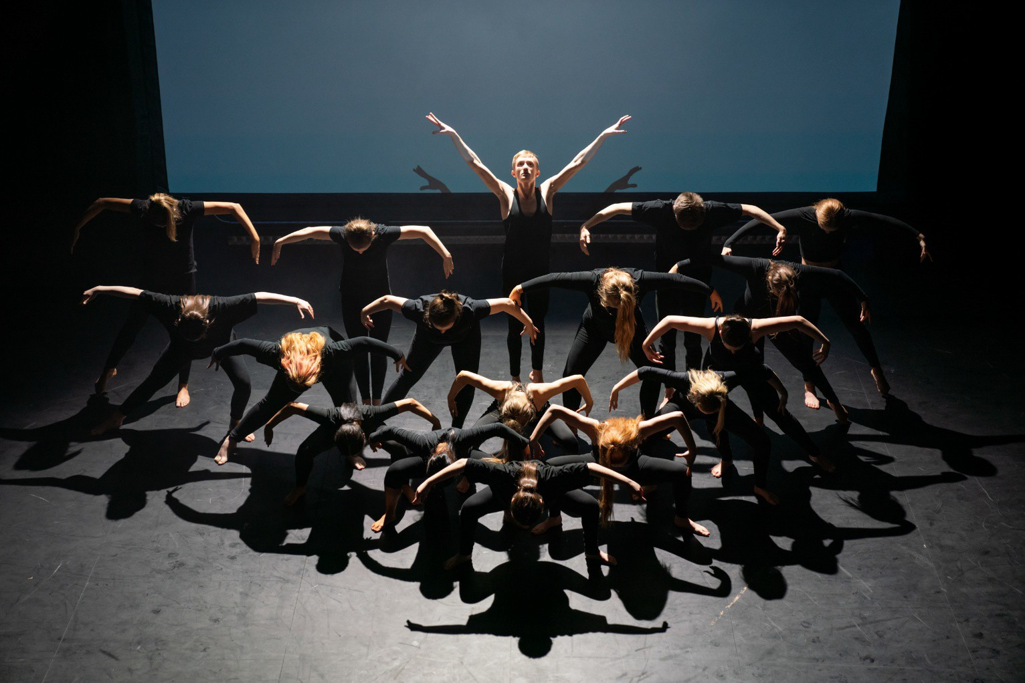

Dance course info here - https://www.leedscitycollege.ac.uk/search- results/?search_term=dance

Theatre Design and Production:
Courses - https://www.leedscitycollege.ac.uk/search- results/?search_term=theatre+design

LSI issue featuring the Leeds City College article on PG86 on the Chroma-Q theatre launch - https://edition.pagesuite- professional.co.uk/html5/reader/production/default.aspx?pubname=&edid=e21e8cb7-16dc-4515-8b31-8fb608a79ba4&pnum=

Theatre Design and Production work in partnership industry leaders A.C.Entertainment Technologies see more here - https://www.leedscitycollege.ac.uk/acentertainmenttechnologies/

Media, TV film:
Courses - https://www.leedscitycollege.ac.uk/search- results/?search_term=journalism
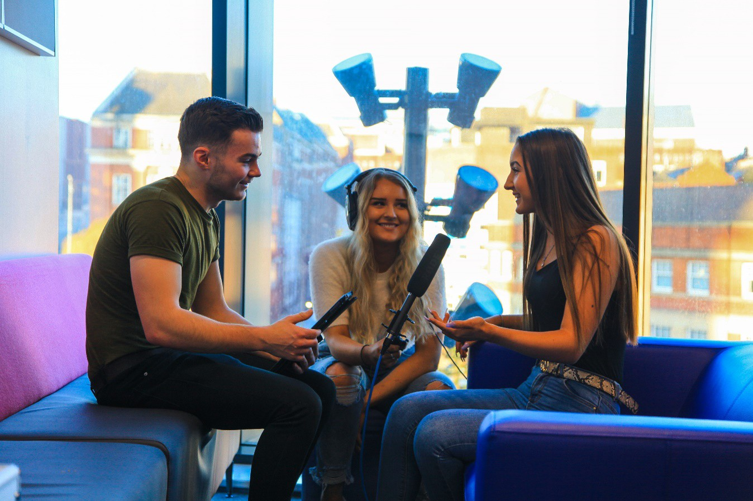

Media videos from this year’s students - https://drive.google.com/drive/folders/1jc4poa2LNSE1OZb8Ty7Ui-ZZhw6Ym_S1

Below are some highlights of this year's student video work:

Zack Wainwright (Promo Video for LCC) - https://drive.google.com/file/d/1fOXJIyi0UAjeumf3XJt0tWlcilo65T4r/view?usp=sharin g

Max Slater (Promo Video for Fullness) - https://drive.google.com/file/d/1FpfJuq4Tw3_1Y6toJYFrav7pKXphc7zM/view?usp=s haring

Harley Winstanley (Work Experience Project for Simon On The Streets) - https://drive.google.com/file/d/1XfzEUKUJhzH3lYZFDdvSt3AD7rJB7Mdx/view?usp= sharing

Cameron Jessup (Music Video) - https://drive.google.com/file/d/1HTusZ_WrdL2l5bOyfzaFrGIyx624tMXP/view?usp=sh aring

Don’t forget to keep updated on your course of interest. Follow us on Instagram @creativeartslcc and visit our creative ideas page: https://www.leedscitycollege.ac.uk/creative-ideas/

Key contacts:
Theatre Design and Production – claire.dunkerley@leedscitycollege.ac.uk Dance – jayne.exton@leedscitycollege.ac.uk
Acting – danielle.bailey@leedscitycollege.ac.uk
Musical Theatre – amy.atkinson@leedscitycollege.ac.uk Film and TV – matthew.farrow@leedscitycollege.ac.uk Journalism – sarah.robinson@leedscitycollege.ac.uk Music Production – dale.guttridge2@leedscitycollege.ac.uk
Music Performance – hayley.russell2@leedscitycollege.ac.uk Level 1 courses – emily.kecic@leedscitycollege.ac.uk

