SCHOOL OF
I
CREATIVE ARTS
LEEDS CITY COLLEGE

Visual and Digital Arts
@®@@@
leedsci tycolleg e.ac.uk

Art & Design Level 1

'STILL LIFE LOCKDOWN' Level 1 students are to create a still life image that demonstrates what they have used to support them throughout lockdown. They may use whatever materials are to hand to create an image that gives insight to their character and personality.

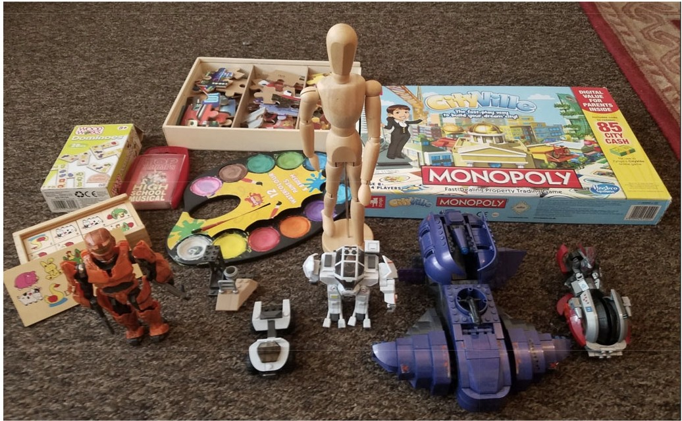
by Ali AI-Qurashi
Art & Design Level 2

Make an image of a landscape. It can be from real life, a photograph or a memory. You can use drawing, painting, mixed media or photography. Also write a paragraph about the image. Your work will be put up in a virtual gallery.

Art & Design Level 3

"A View From The Room" - Produce a single image in any media of a view from a window in your house. Be as imaginative or literal as you like, working in any medium and any size. You are to bring your image with you on your induction day.

"Me" - Produce a self-portrait, either drawn or painted in any media and on any surface. No filters please! Your portrait will then be used in a project seen by artist Lydia Blakeley. You are to bring your self portrait with you on your induction day.
;L /Ml DFUL
CIPD
- VEMPLOYER

Leeds City College Is a member of Lumlnate Education Group

@®@@@)
I
leedsci tycolleg e.ac. uk
SCHOOL OF CREATIVE ARTS
LEEDS CITY COLLEGE

Fashion & Textiles Level 3

Fashion focused brief - What I'd rather bei wearing
Lockdown has meant that you might have mostly been living in pyjamas and joggers for the last 8 weeks. It also might mean that you have missed out on something you love or were really looking forward to such as sports, celebrations, events, meeting friends and just "normal" life.

We would like you to show us at least 3 outfits that you would rather be wearing, and tell us why. These outfits can be photographs, paintings, sketches, embroidery, social media posts, a range of techniques. How you document this is completely up to you.

The only restriction is please make your work square (of any size as long as the height and width is the same). This is so your work can be fieatured in an exhibition when college opens for the new term.

Textiles focused brief
During lockdown creativity has been key to keeping us entertained, sometimes having to think of alternative solutions for our creative projects. It is also a great time to just give something a go. With this in mind choose one or more objects from your surroundings, this could be a plant, item of clothing, a pencil, a tool, favourite food or drink or any selection of everyday objects.
- Use materials you have around you to cn3ate a piece of work representing that object. Think about its form, texture, colour etc.
- This could be a collage using all sorts of materials, a drawing using charcoal from the bbq, a painting, a 3D model, machine or hand embroidery or applique. Show us your skills and experiment with others. Feel fme to do more than one!
- Here is a link to some ideas of using alternative materials to create artwork. https://www.pinterest.co.uk/ameliatextiles/covid-19/
- When photographing your work use good natural light and make sure you can crop it to a square format as it will be used as part of a display at the start of term.
�-
CIPD
L

  - op1-c. c :entre
_/MINDFUL VEMPLOYER

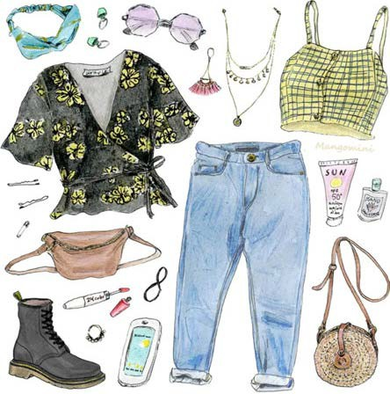
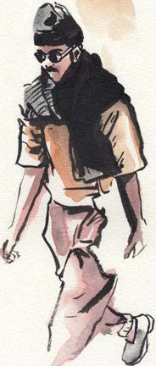
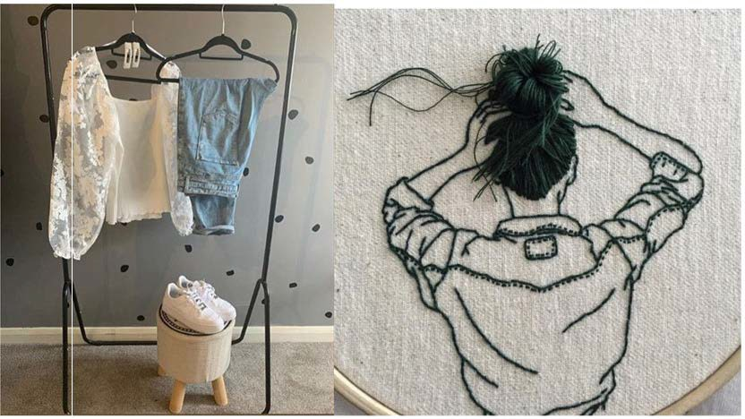
Leeds City College Is a member of Lumlnate Education Group

Graphics Level 3 new starters

“My square”
Create a self portrait or an image that represents you, using any style and materials you would like. For instance you could use paint, pencils, pastels, digital software, cut paper, plasticine, photography, found objects (leaves, bottle tops, buttons
etc) anything goes.
- The final image must be square in format (same size wide as tall)
- The image must be you, or represent you somehow
- If using photography you should be creative. This means not just simply taking a selfie and adding some filters to it.
- If you have made a 3D piece (collage, sculpture), take a good photograph and submit that.
- All images should be sent at the best resolution possible
- Name your image with your name then use link below to drop your image into the folder “MY SQUARE” on Google Drive (you may need to sign into a gmail address to do this)
https://drive.google.com/drive/ folders/1hWA9p0m1tBr8u_SRYno2vY8S0_BAjMhP
All of your images will then be compiled into a massive poster for display at the start of term.
Have fun!

Photography Level 2 / Graphics Level 2 and new graphics applicants
- Submit a square drawing / photo. to be compiled into a poster
- Submit a square self portrait made in any style and with any materials to be compiled into a poster
- Find a bad piece of design (poster, logo, meme…) and redesign it
Make a ‘sculpture’ out of stuﬀ to be recycled (submit photograph)

Photography Level 3 & Level 2 (I have this in a Word Document, the formatting is better)

LCC Photography Summer Club…

Hi all,
Welcome to Photography at Leeds City College. In order to get you started and warmed up for your upcoming year of study, especially after such a long period in lockdown, we have decided to help you get started with some photography activities. This will give you the chance to meet other students at LCC doing photography and showcase a bit of your own work.

  - We have created a Facebook Group called “LCC Photography Summer Club” - this is the link; https://www.facebook.com/groups/1554563508083686/? ref=group_headerhhh
    - Please locate the group on Facebook and ask to join (if you don’t have a Facebook account, please set one up as we will use Facebook throughout the year).

  - Practical Challenge: Squares and Circles.
    - Make a series of six images based on your interpretation of the title “Squares and Circles”. These can be taken on any camera including your phone camera. Please stay safe, only leave home if you have to.
    - Give a brief description of why you made each image.
We will look at these images in the 1st week of the course but you can post them to the Facebook group as well.

  - Written Challenge: Choose a photograph by your favourite photographer.
    - Name the photographer
    - Name the photograph if it has a name (please include a copy of the image if possible).
    - Write a paragraph about why you like this photograph We will look at this in the 1st week of the course.

  - We would also like you to show us some of your own work. Please post

  - new images to the Facebook group. You can say as much or as little about them as you want.

Have a great summer, stay safe and we will look forward to seeing you all in September!

All L3 Yr 2 Art, Photography & Graphics (FYI & incase this info is needed?)

Students are selecting, formatti ng and submitti ng images and an artist statement for a virtual online Exhibition and course Catalogue.

